Template for OK 2018 Conference Proceedings

First A. Author, Second B. Author, Jr., and Third C. Author
Faculty of Electrical Engineering, Technical University of …
Abstract—these instructions give you guidelines for preparing papers for OK 2018 Conference Proceedings. Use this document as a template if you are using Microsoft Word 6.0 or later version. Otherwise, use this document as an instruction set. The electronic file of your paper will be formatted further by OK 2018 editors. Define all symbols used in the abstract. Do not cite references in the abstract.

Index Terms—About four key words or phrases in alphabetical order, separated by commas.

INTRODUCTION
T
HIS document is a template for Microsoft Word 6.0 or later versions. (If you are reading a paper or PDF version of this document, please, use this document as an instruction set.) Just type over sections or cut and paste from another document and use markup styles. The pull-down style menu is at the left of the Formatting Toolbar at the top of your Word window (for example, the style at this point in the document is “Text”). Highlight a section that you want to designate with a certain style, then select the appropriate name on the style menu. The style will adjust your fonts and line spacing. Do not change the font sizes or line spacing to squeeze more text into a limited number of pages. Use italics for emphasis; do not underline.
To insert images in Word, position the cursor at the insertion point and either use Insert | Picture | From File or copy the image to the Windows clipboard and then Edit | Paste Special | Picture (with “float over text” unchecked).
Conference organizers will do the final format control of your paper. Please observe carefully the full paper format requirements.

Procedure for Paper Submission

Final Stage
Please send the final version (after your paper has been accepted) by email to team@action-m.com in the required template as stated bellow before September 21, 2018.

Figures
Format and save your graphic images using a suitable graphics processing program that will allow you to create the images as PostScript (PS), Encapsulated PostScript (EPS), or Tagged Image File Format (TIFF), size them and adjust the resolution settings. If you created your source files in one of the following formats, you will be able to submit the graphics without the need of converting them to a PS, EPS, or TIFF file: Microsoft Word, Microsoft PowerPoint, Microsoft Excel, or Portable Document Format (PDF).

Electronic Image Files (Optional)
Import your source files are in one of the following formats: Microsoft Word, Microsoft PowerPoint, Microsoft Excel, or Portable Document Format (PDF); you will be able to submit the graphics without converting it to a PS, EPS, or TIFF files. Image quality is very important to how your graphics will reproduce. Even though we can accept graphics in many formats, we cannot improve your graphics if they are of poor quality when we receive them. If your graphics looks low in quality on your printer or monitor, please keep in mind that we cannot improve its quality after submission.
If you are importing your graphics into this Word template, please use the following steps:
Under the option EDIT select PASTE SPECIAL. A dialog box will open, select "paste picture", then click OK. Your figure should now be inserted in the Word Document.
If you are preparing images in TIFF, EPS, or PS formats, note the following: High-contrast line figures and tables should be prepared with 600 dpi resolution and saved with no compression, 1 bit per pixel (monochrome), with file names in the form of “fig3.tif” or “table1.tif.”
Photographs and grayscale figures should be prepared with 300 dpi resolution and saved with no compression, 8 bits per pixel (gray scale).

Sizing of Graphics
Most charts graphs and tables are one column wide (3 1/2 inches or 21 picas) or two-column width (7 1/16 inches, 43 picas wide). We recommend that you avoid sizing figures less than one column wide, as extreme enlargements may distort your images and result in poor reproduction. Therefore, it is better if the image is slightly larger, as a minor reduction in size should not have an adverse effect the quality of the image.

Color Graphics Requirements
Photos and figures in the proceedings book will appear in black-and-white. Color images will be kept in the electronic proceedings (CD-ROM). Color graphics in the following formats is acceptable: EPS, PS, TIFF, Word, PowerPoint, Excel, and PDF. The resolution of a RGB color TIFF file should be 400 dpi.

TABLE I
Units for Magnetic Properties
Symbol | Quantity | Conversion from Gaussian and  CGS EMU to SI ª
Φ | magnetic flux | 1 Mx → 10⁻⁸ Wb = 10⁻⁸ V·s
B | magnetic flux density,  magnetic induction | 1 G → 10⁻⁴ T = 10⁻⁴ Wb/m²
H | magnetic field strength | 1 Oe → 10³/(4π) A/m
m | magnetic moment | 1 erg/G = 1 emu  → 10⁻³ A·m² = 10⁻³ J/T
M | magnetization | 1 erg/(G·cm³) = 1 emu/cm³  → 10³ A/m
4πM | magnetization | 1 G → 10³/(4π) A/m
σ | specific magnetization | 1 erg/(G·g) = 1 emu/g → 1 A·m²/kg
j | magnetic dipole  moment | 1 erg/G = 1 emu  → 4π × 10⁻¹⁰ Wb·m
J | magnetic polarization | 1 erg/(G·cm³) = 1 emu/cm³  → 4π × 10⁻⁴ T
χ, κ | susceptibility | 1 → 4π
χ_{ρ} | mass susceptibility | 1 cm³/g → 4π × 10⁻³ m³/kg
μ | permeability | 1 → 4π × 10⁻⁷ H/m  = 4π × 10⁻⁷ Wb/(A·m)
μ_{r} | relative permeability | μ → μ_{r}
w, W | energy density | 1 erg/cm³ → 10⁻¹ J/m³
N, D | demagnetizing factor | 1 → 1/(4π)
Vertical lines are optional in tables. Statements that serve as captions for the entire table do not need footnote letters.
ªGaussian units are the same as cgs emu for magnetostatics; Mx = maxwell, G = gauss, Oe = oersted; Wb = weber, V = volt, s = second, T = tesla, m = meter, A = ampere, J = joule, kg = kilogram, H = henry.

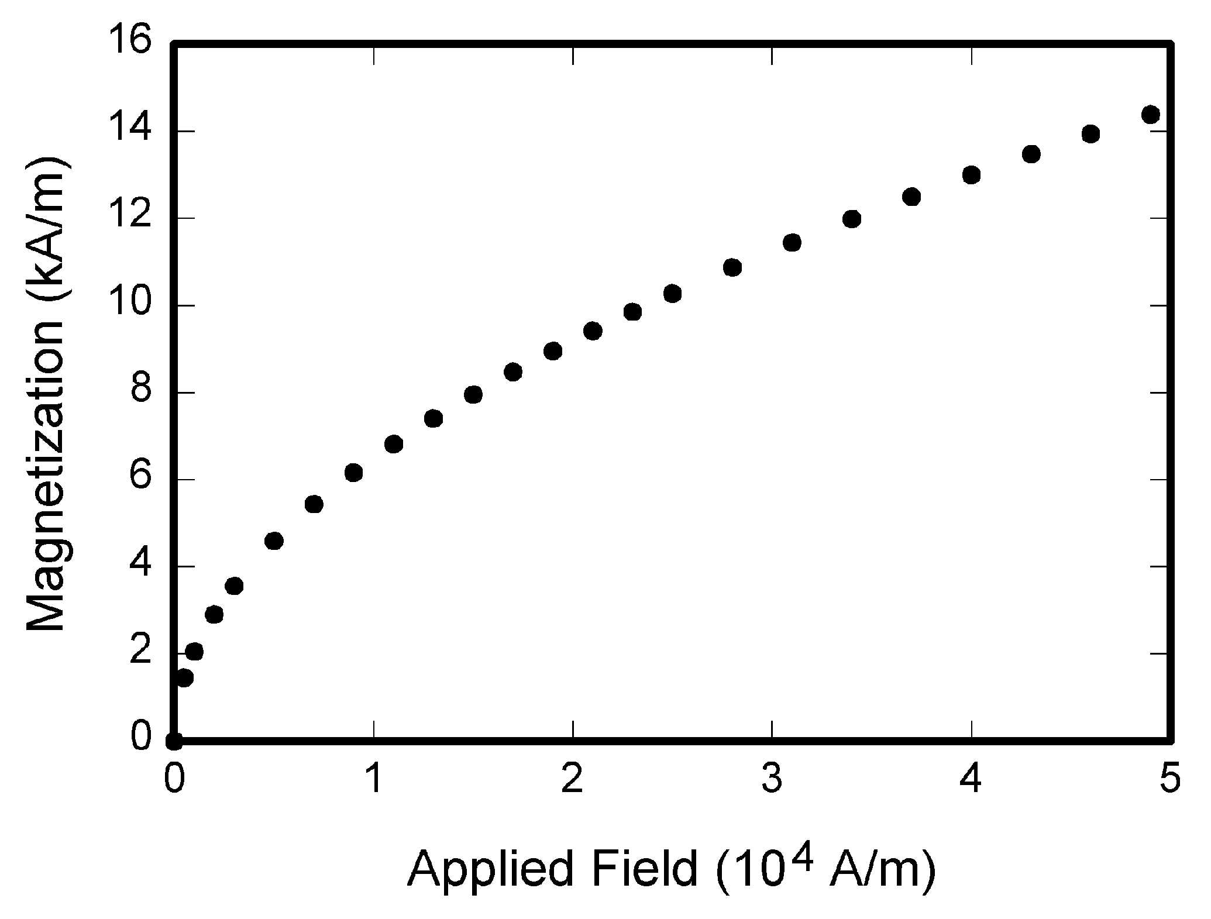
Fig. 1. Magnetization as a function of applied field. Note that “Fig.” is abbreviated. There is a period followed by space after the "Fig." followed by the figure number and two spaces. It is good practice to explain the significance of the figure in the caption.

MATH
If you are using Word, use either the Microsoft Equation Editor or the MathType add-on (http://www.mathtype.com) for equations in your paper (Insert | Object | Create New | Microsoft Equation or MathType Equation). “Float over text” should not be selected.

Units
Use SI units. An exception is when English units are used as identifiers in trade, such as “3½-in disk drive.” Avoid combining SI and CGS units, such as current in amperes and magnetic field in oersteds. This often leads to confusion because equations do not balance dimensionally. If you must use mixed units, clearly state the units for each quantity in an equation.

Helpful Hints

Figures and Tables
Large figures and tables may span both columns. Place figure captions below the figures; place table titles above the tables. If your figure has two parts, include the labels “(a)” and “(b)” as part of the artwork. Please verify that the figures and tables you mention in the text actually exist. Please do not include captions as part of the figures. Do not put captions in “text boxes” linked to the figures. Do not put borders around the outside of your figures. Use the abbreviation “Fig.” even at the beginning of a sentence. Do not abbreviate “Table.” Tables are numbered with Roman numerals.
Figure axis labels are often a source of confusion. Use words rather than symbols. As an example, write the quantity “Magnetization,” or “Magnetization M,” not just “M.” Put units in parentheses. Do not label axes with units only. As in Fig. 1, for example, write “Magnetization (A/m)” or “Magnetization (Am⁻¹),” not just “A/m.” Do not label axes with a ratio of quantities and units. For example, write “Temperature (K),” not “Temperature/K.”
Multipliers can be especially confusing. Write “Magnetization (kA/m)” or “Magnetization (10³ A/m).” Do not write “Magnetization (A/m) × 1000” because the reader would not know whether the top axis label in Fig. 1 meant 16000 A/m or 0.016 A/m. Figure labels should be legible, approximately 8 to 12 point type.

References
Put citation numbers consecutively in square brackets [1]. The sentence punctuation follows the brackets [2]. Multiple references [2], [3] are each numbered with separate brackets [1]–[3]. When citing a section in a book, please give the relevant page numbers [2]. In sentences, refer simply to the reference number, as in [3]. Do not use “Ref. [3]” or “reference [3]” except at the beginning of a sentence: “Reference [3] shows ... .” Please do not use automatic endnotes in Word, rather, type the reference list at the end of the paper using the “References” style.
Number the footnotes separately in superscripts (Insert | Footnote). Place the actual footnote at the bottom of the column in which it is cited; do not put footnotes in the reference list (endnotes). Use letters for table footnotes (see Table I).
Please note that the references at the end of this document are in the preferred referencing style. Give all authors’ names; do not use “et al.” unless there are six authors or more. Use a space after authors’ initials. Papers that have not been published should be cited as “unpublished” [4]. Papers that have been accepted for publication, but not yet specified for an issue should be cited as “to be published” [5]. Papers that have been submitted for publication should be cited as “submitted for publication” [6]. Please give affiliations and addresses for private communications [7].
Capitalize only the first word in a paper title, except for proper nouns and element symbols. For papers published in translation journals, please give the English citation first, followed by the original foreign-language citation [8].

Abbreviations and Acronyms
Define abbreviations and acronyms the first time they are used in the text, even after they have already been defined in the abstract. Abbreviations such as IEEE, SI, ac, and dc do not have to be defined. Abbreviations that incorporate periods should not include spaces: write “C.N.R.S.,” not “C. N. R. S.” Do not use abbreviations in the title unless they are unavoidable (for example, “OK” in the title of this article).

Equations
Number the equations consecutively with equation numbers in parentheses, flush with the right margin, as in (1). First use the equation editor to create the equation. Then select the “Equation” markup style. Press the tab key and write the equation number in parentheses. To make your equations more compact, you may use the solidus ( / ), the exp function, or appropriate exponents. Use parentheses to avoid ambiguities in denominators. Punctuate equations when they are part of a sentence, as in

(1)

Be sure that the symbols in your equation have been defined before the equation appears or immediately following it. Italicize symbols (T might refer to temperature, but T is the unit tesla). Refer to “(1),” not “Eq. (1)” or “equation (1),” except at the beginning of a sentence: “Equation (1) is ... .”

Other Recommendations
Use one space after periods and colons. Hyphenate complex modifiers: “zero-field-cooled magnetization.” Avoid dangling participles, such as, “Using (1), the potential was calculated.” [It is not clear who or what used (1).] Write instead, “The potential was calculated by using (1),” or “Using (1), we calculated the potential.”
Use a zero before decimal points: “0.25,” not “.25.” Use “cm³,” not “cc.” Indicate sample dimensions as “0.1 cm × 0.2 cm,” not “0.1 × 0.2 cm².” The abbreviation for “seconds” is “s,” not “sec.” Do not mix complete spellings and abbreviations of units: use “Wb/m²” or “webers per square meter,” not “webers/m².” When expressing a range of values, write “7 to 9” or “7-9,” not “7~9.”
A parenthetical statement at the end of a sentence is punctuated outside of the closing parenthesis (like this). (A parenthetical sentence is punctuated within the parentheses.) In American English, periods and commas are within quotation marks, like “this period.” Other punctuation is “outside”! Avoid contractions; for example, write “do not” instead of “don’t.” The serial comma is preferred: “A, B, and C” instead of “A, B and C.”
If you wish, you may write in the first person singular or plural and use the active voice (“I observed that ...” or “We observed that ...” instead of “It was observed that ...”). Remember to check spelling. If your native language is not English, please get a native English-speaking colleague to carefully proofread your paper.

Some Common Mistakes
The word “data” is plural, not singular. The subscript for the permeability of vacuum µ₀ is zero, not a lowercase letter “o.” The term for residual magnetization is “remanence”; the adjective is “remanent”; do not write “remnance” or “remnant.” Use the word “micrometer” instead of “micron.” A graph within a graph is an “inset,” not an “insert.” The word “alternatively” is preferred to the word “alternately” (unless you really mean something that alternates). Use the word “whereas” instead of “while” (unless you are referring to simultaneous events). Do not use the word “essentially” to mean “approximately” or “effectively.” Do not use the word “issue” as a euphemism for “problem.” When compositions are not specified, separate chemical symbols by en-dashes; for example, “NiMn” indicates the intermetallic compound Ni_{0.5}Mn_{0.5} whereas “Ni–Mn” indicates an alloy of some composition Ni_{x}Mn_{1-x}.
Be aware of the different meanings of the homophones “affect” (usually a verb) and “effect” (usually a noun), “complement” and “compliment,” “discreet” and “discrete,” “principal” (e.g., “principal investigator”) and “principle” (e.g., “principle of measurement”). Do not confuse “imply” and “infer.”
Prefixes such as “non,” “sub,” “micro,” “multi,” and “ultra” are not independent words; they should be joined to the words they modify, usually without a hyphen. There is no period after the “et” in the Latin abbreviation “et al.” (it is also italicized). The abbreviation “i.e.,” means “that is,” and the abbreviation “e.g.,” means “for example” (these abbreviations are not italicized).

Editorial Policy
Do not submit a reworked version of a paper you have submitted or published elsewhere. Do not publish “preliminary” data or results. The submitting author is responsible for obtaining agreement of all coauthors and any consent required from sponsors before submitting a paper. We strongly discourage courtesy authorship. It is the obligation of the authors to cite relevant prior work.
For conference-related papers, the decision to accept or reject a paper is made by the conference TPC; the recommendations of the reviewers are advisory only. Undecipherable English is a valid reason for rejection.

Publication Principles
Authors should consider the following points:
- Technical papers submitted for publication must advance the state of knowledge and must cite relevant prior work.
- The length of a submitted paper should be commensurate with the importance, or appropriate to the complexity, of the work. For example, an obvious extension of previously published work might not be appropriate for publication or might be adequately treated in just a few pages.
- Authors must convince both peer reviewers and the editors of the scientific and technical merit of a paper; the standards of proof are higher when extraordinary or unexpected results are reported.
- Because replication is required for scientific progress, papers submitted for publication must provide sufficient information to allow readers to perform similar experiments or calculations and use the reported results. Although not everything need be disclosed, a paper must contain new, useable, and fully described information. For example, a specimen’s chemical composition need not be reported if the main purpose of a paper is to introduce a new measurement technique. Authors should expect to be challenged by reviewers if the results are not supported by adequate data and critical details.

Conclusion
A conclusion section is not required. Although a conclusion may review the main points of the paper, do not replicate the abstract as the conclusion. A conclusion might elaborate on the importance of the work or suggest applications and extensions.

Appendix
Appendixes, if needed, appear before the acknowledgment.

Acknowledgment
The preferred spelling of the word “acknowledgment” in American English is without an “e” after the “g.” Use the singular heading even if you have many acknowledgments. Avoid expressions such as “One of us (S.B.A.) would like to thank ... .” Instead, write “F. A. Author thanks ... .”

References
- G. O. Young, “Synthetic structure of industrial plastics (Book style with paper title and editor),” in Plastics, 2nd ed. vol. 3, J. Peters, Ed. New York: McGraw-Hill, 1964, pp. 15–64.
- W.-K. Chen, Linear Networks and Systems (Book style). Belmont, CA: Wadsworth, 1993, pp. 123–135.
- H. Poor, An Introduction to Signal Detection and Estimation. New York: Springer-Verlag, 1985, ch. 4.
- B. Smith, “An approach to graphs of linear forms (Unpublished work style),” unpublished.
- E. H. Miller, “A note on reflector arrays (Periodical style—Accepted for publication),” IEEE Trans. Antennas Propagat., to be published.
- J. Wang, “Fundamentals of erbium-doped fiber amplifiers arrays (Periodical style—Submitted for publication),” IEEE J. Quantum Electron., submitted for publication.
- C. J. Kaufman, Rocky Mountain Research Lab., Boulder, CO, private communication, May 1995.
- Y. Yorozu, M. Hirano, K. Oka, and Y. Tagawa, “Electron spectroscopy studies on magneto-optical media and plastic substrate interfaces (Translation Journals style),” IEEE Transl. J. Magn.Jpn., vol. 2, Aug. 1987, pp. 740–741 [Dig. 9th Annu. Conf. Magnetics Japan, 1982, p. 301].
- M. Young, The Techincal Writers Handbook. Mill Valley, CA: University Science, 1989.
- J. U. Duncombe, “Infrared navigation—Part I: An assessment of feasibility (Periodical style),” IEEE Trans. Electron Devices, vol. ED-11, pp. 34–39, Jan. 1959.
- S. Chen, B. Mulgrew, and P. M. Grant, “A clustering technique for digital communications channel equalization using radial basis function networks,” IEEE Trans. Neural Networks, vol. 4, pp. 570–578, Jul. 1993.
- R. W. Lucky, “Automatic equalization for digital communication,” Bell Syst. Tech. J., vol. 44, no. 4, pp. 547–588, Apr. 1965.
- S. P. Bingulac, “On the compatibility of adaptive controllers (Published Conference Proceedings style),” in Proc. 4th Annu. Allerton Conf. Circuits and Systems Theory, New York, 1994, pp. 8–16.
- G. R. Faulhaber, “Design of service systems with priority reservation,” in Conf. Rec. 1995 IEEE Int. Conf. Communications, pp. 3–8.
- W. D. Doyle, “Magnetization reversal in films with biaxial anisotropy,” in 1987 Proc. INTERMAG Conf., pp. 2.2-1–2.2-6.
- G. W. Juette and L. E. Zeffanella, “Radio noise currents n short sections on bundle conductors (Presented Conference Paper style),” presented at the IEEE Summer power Meeting, Dallas, TX, Jun. 22–27, 1990, Paper 90 SM 690-0 PWRS.
- J. G. Kreifeldt, “An analysis of surface-detected EMG as an amplitude-modulated noise,” presented at the 1989 Int. Conf. Medicine and Biological Engineering, Chicago, IL.
- J. Williams, “Narrow-band analyzer (Thesis or Dissertation style),” Ph.D. dissertation, Dept. Elect. Eng., Harvard Univ., Cambridge, MA, 1993.
- N. Kawasaki, “Parametric study of thermal and chemical nonequilibrium nozzle flow,” M.S. thesis, Dept. Electron. Eng., Osaka Univ., Osaka, Japan, 1993.
- J. P. Wilkinson, “Nonlinear resonant circuit devices (Patent style),” U.S. Patent 3 624 12, July 16, 1990.

It is recommended that footnotes be avoided (except for the unnumbered footnote with the receipt date on the first page). Instead, try to integrate the footnote information into the text.

